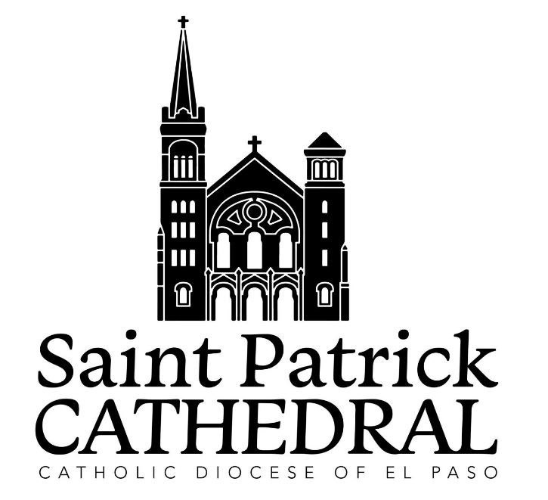

Traducido

del

inglés

al

español

-

www.onlinedoctranslator.co
m
Saint Patrick Cathedral

1118 North Mesa, El Paso, TX 79902 915-533-4451
Sacrament of Marriage: Guidelines & Preparation
Who may be married at St. Patrick's?
Anyone who lives within the boundaries of St Patrick's parish, or is known to us through Religious Education, parish registration, Stewardship, or any parish activity/ministry.
If a couple wishing to be married at St. Patrick's is from another parish, they must first receive permission from their pastor.
Importance is always given to a couple getting married in their own community, and couples are encouraged to marry in the parish community to which they belong.
The stipend is $500, and a $250 deposit is required at the initial interview and registration. *Please keep in mind that your requested wedding date cannot be guaranteed until the deposit is submitted on the day of the interview.
Necessary Documents
- - Baptismal Certificate: A Roman Catholic must provide evidence of his/her baptism. A recent certificate (issued after your meeting with the pastor) must be obtained from the church of your baptism and submitted to the office. Those of other Christian denominations must also show proof of baptism.
- - First Communion & Confirmation Certificates: We will make copies of the original certificates if you have them. When you receive your baptismal certificate, see if these sacraments have been noted on the back of the certificate.
- - Questionnaire: Every couple is required to complete a personal information form. At the time of your first appointment, you will complete this form with the priest, and your date and time for marriage will also be confirmed and registered in the parish calendar.
- - Affidavit of Free Status: Every individual needs two (2) witnesses to come to the office and give testimony that he/she is free to marry. This testimony is usually obtained from a parent or family member.
- - A valid Texas Marriage License must be obtained and given to the office at least 72 hours before your scheduled wedding.
- - Dispensations are needed for those marrying a non-Catholic. The fee is $10, checks made payable to the Diocese of El Paso. Your recent baptismal certificate will be required along with a request for a dispensation.

Marriage Preparation
Diocesan policy states that each couple must contact the priest and/or parish office at least six months in advance of the anticipated wedding date.
During this time, the couple is expected to provide the above forms and complete the following:
1- Participation at Engaged Encounter weekend; and/or
2 - Participation in Marriage Preparation classes.
What about Previous Marriages?
- If you are a Catholic and were previously married in the Catholic Church, you must first obtain an annulment through the Diocesan Marriage Tribunal, 872-8402, before beginning preparations for marriage.
- If you are a Catholic and have a previous civil marriage, you need to provide the official marriage license, official divorce decree, and complete a "Canonical Lack of Form" with the priest. There is a $25 fee to the Diocese of El Paso.
The Day of Your Wedding
The wedding party should be at the church 30 minutes before the scheduled time. There are no special dressing rooms, and everyone should arrive dressed and ready for the ceremony.
Because of the Saturday schedule, any wedding that begins late may be shortened in order to maintain the parish's Saturday schedule. Please be on time.
The Wedding Mass
When you complete the Engaged Encounter weekend and/or Marriage Preparation course, you will receive a booklet with prayers and readings for your wedding.
Read the booklet and information carefully and take your time planning the ceremony and choosing the readings. When choosing the readings, you should also choose people to read the readings at your wedding - people who read well.
Three official rites may be used for a Catholic wedding ceremony:
1 - Wedding within Mass,
- - Wedding Outside of Mass, and
- - Wedding Between a Catholic and a Catechumen or a Non-Christian.
The couple should consider how important the Mass is in their lives and whether they attend Mass on a regular basis. If you are not comfortable or familiar with participation in the Mass, you should consider having the Wedding Outside of Mass.
For Catholics marrying a non-Catholic, the norm is the Wedding Outside of Mass. When marrying a Catechumen or a Non-Christian, the rite used is the Wedding Between a Catholic and a Catechumen or a Non-Christian.
Flowers
No artificial flowers. You should consult with the Altar Society, as they prepare flowers weekly. No flowers are placed in front of, or on the sides, of the altar.
No arches, aisle runners, candelabra, or flower petals thrown on the floor.
You may put ribbons or flowers on the pews using hooks, no tape.
If you are getting married during the Christmas or Easter season, you should be aware of the flowers that will already be in the church.
Music
Music is encouraged for your celebration. The following musicians are approved for the Cathedral, and they can be of assistance to you in planning the music for your wedding:

LeeAnn Beck | (915) 433-2824
Adrian Zamora | (915) 533-8369
David Torres | (915) 540-2162
Ana Lilia Sanchez | (915) 887-8071 | (Spanish)
Blanca Terrazas | (915) 373-1358 | (Spanish)
* Please note that music fees are not included in the marriage preparation fee. Couples are responsible for making separate arrangements with the music coordinators regarding music selection and any associated costs.
* You MUST request permission to use anyone who is not on the approved list above.
* Mariachi bands are NOT permitted to be used during the wedding ceremony.
Only religious music may be sung during the wedding liturgy. Classical music and marches are acceptable with the exception of Wagner's Bridal March (Here Comes The Bride). Your wedding is a celebration of faith and the music should reflect this. It should be planned as if it were a Sunday Mass and all the Mass parts must be sung by a vocalist and/or cantor.
Other items...
Throwing bird seed, rice, etc. inside or outside the church is not permitted as it is a hazard and a legal liability for the parish and for you. We also do not permit bubbles as they stain the floor and sidewalks. These items are best kept for the couple's departure from the wedding reception.

Photographers
The photographer should speak with the priest before the ceremony for any special instructions.
Photographers are asked to choose one spot from which to take pictures so as not to be moving around during the ceremony. There is also a balcony from which pictures can be taken.

The Wedding Rehearsal
Rehearsals are scheduled for the week of the wedding, usually on the Thursday before the wedding. Please call at least two weeks before your wedding to schedule your rehearsal.
Confessions will not be a part of your rehearsal. If you or any member of the wedding party wishes to celebrate the Sacrament of Reconciliation (confession) they should do so before the wedding.
What happened to "giving the bride away"?
Many people have grown up seeing weddings on TV where the father walks the bride down the aisle and then formally "gives her away" to the groom. This is not part of the Roman Catholic ceremony.
It is customary at Catholic weddings for the bride and groom to be escorted by their parents, or to walk (process) together as a couple.
Couples who are civilly married often choose to process together as a couple. If you have children, they may accompany you in the procession.
Convalidation
- Blessing of Civil Marriages -
1 - Submit all necessary documents as listed above under the heading "Necessary Documents." 2 - Please bring your marriage license to the office so we can make a copy for your file.
3 - If you have a previous marriage, the guidelines for Previous Marriages apply. 4 - Please follow all guidelines for the wedding liturgy.

