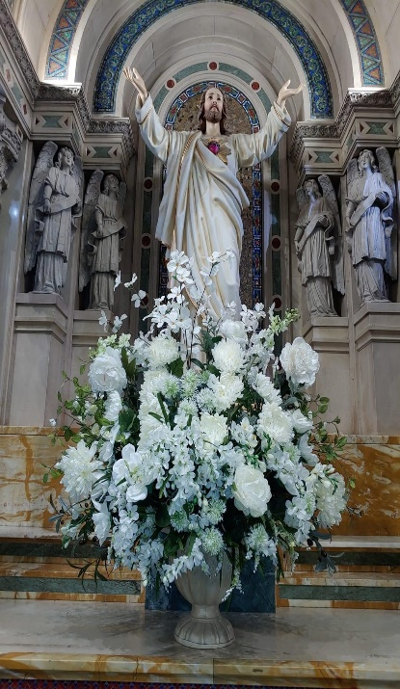
May our Lord Jesus Christ be with all of you.
Because of the Coronavirus Pandemic,
we, the Community of Saint Patrick Cathedral,
will begin our Religious Formation classes virtually and then,
when we feel that it is safe enough to return to the classrooms,
will continue with a Hybrid program.

Please select your preferred option:
Virtual learning 100% Online.
Hybrid program with returning to the classroom when declared safe.

Candidate for the Sacraments Information
Current School Grade
Registering For
Last Name First Name

Middle Name Gender

Confirmation Candidate Email Address

Parent/Guardian Personal Information
Home Phone Number Cell Phone Number

Father’s Name Mother’s Name

Email Address

Current Residence Information
Street Address

City and State Zip Code

Sacramental Information
Church of Baptism

City and State Baptism Date

First Holy Communion Church

City and State First Holy Communion Date

Additional Documents Required for Registration
Please email or bring the following documentation to the Parish:
- Birth Certificate (only for those candidates seeking the Sacrament of Baptism)
- Baptismal Certificate
- First Holy Communion Certificate (Confirmation Candidates)
- Medical Form A
- Form B (Confirmation Candidates)
REGISTRATION FEES MUST BE PAID IN FULL AT THE TIME OF REGISTRATION:
First Holy Communion: $50.00 for 1 child; $25.00 for each additional child
Confirmation: $50.00 per candidate
Adult Confirmation: $60.00 per candidate
Note: Children and Youth will not be officially registered until Parents complete the Safe Environment Requirement.
Please inform the office of any other vital information you think necessary to assist your family in receiving the proper pastoral care from this community. If you pay online, please annotate the transaction number in this space.

Thank you so much for choosing Saint Patrick Cathedral
to continue your journey in your Religious Formation.

